

A COMPARATIVE STUDY OF ETF VOLATILITY PREDICTION BETWEEN LSTM AND ARIMA
Final Report of DRIVERS Project
Presented to
Prof Debraj Bhattacharjee
By
Krishnakant Vyas
PGB240047
FLAME School of Business
FLAME University
Academic Year 2025-2026

Table of Contents
Guidance Certificate 3
List of Tables 4
List of Figures 4
Abstract / Executive Summary 5
1. Introduction 7
1.1 Background and Context 7
1.2 Rationale for the Study 8
2. Literature Review and Secondary Research 8
2.1 ETFs: Growth and Market Significance 8
2.2 Times Series Forecasting: ARIMA 9
2.3 Deep Learning: LSTM 9
2.4 Investor Perceptions of AI and Financial Risk 9
2.5 Significant Market Events and Volatility 10
3. Research Objective 10
4. Methodology 11
4.1 Method Design 11
4.2 Secondary Data: Description and Preprocessing 11
4.3 Primary Data: Survey Design and Administration 11
4.4 ARIMA Model 12
4.5 LSTM Model 12
4.6 Evaluation Metrics 12
5. Analysis and Findings 12
5.1 Primary Survey Findings 12
5.1.1 Q1: Investment Status of Respondents 13
5.1.2 Q2: Familiarity with Market Risk Measures 13
5.1.3 Q3: Most Impactful Global Market Event 14
5.1.4 Q4: Trust in AI/ML Tools For Investment Decisions 14
5.1.5 Q5: Investment Decision Priority 15
5.2 Secondary Data Analysis: ARIMA Model Results 15
5.3 LSTM Model Architecture and Training 16
5.4 LSTM Prediction Results 17
5.5 Comparative Model Evaluation 17
6. Discussion 18
6.1 Why ARIMA Underperforms 18
6.1 Why LSTM Outperforms 18
6.3 Triangulation with Primary Survey Results 18
6.4 Implications for the ETF Industry 19
6.5 Limitations 19
7. Conclusion 19
References 20

Guidance Certificate

Date

This is to certify that Mr , postgraduate student of FLAME University, Pune has completed the DRIVERS Project under my guidance. The title of the project was: A Comparative Study Of ETF Volatility Prediction Between LSTM And ARIMA

Overall, I am satisfied with the quality of the student's work, and I wish the student all the success in the future.

Date:
Place:

Signature:
Name of Faculty Mentor
Designation

List of Tables

Table 1: Survey Results Q1) Investment Status of Respondents
Table 2: Survey Results Q2) Familiarity with Market Risk Measures
Table 3: Survey Results Q3) Most Impactful Global Market Event
Table 4: Survey Results Q4) Trust in AI/ML Tools for Investment Decisions
Table 5: Survey Results Q5) Investment Decision Priority
Table 6: ARIMA SARIMAX (5,1,2) Model Parameters and Diagnostics
Table 7: LSTM Model Architecture
Table 8: Model Performance Comparison ARIMA vs. LSTM
Table 9: Sample Actual vs. Predicted Values First 5 Test Observations

List of Figures

Figure 1: ARIMA Model Predictions vs. Actual S&P Volatility 30D (Test Set)
Figure 2: LSTM Model Predictions vs. Actual S&P Volatility 30D (Test Set)
Figure 3: ARIMA vs. LSTM Combined Comparison Plot S&P Volatility 30D

Note: Figures 1, 2, and 3 are generated from the Python analysis in Google Colab and are to be inserted here from the saved plots.

Abstract / Executive Summary

Exchange-Traded Funds (ETFs) have come out to be one of the most embraced investment vehicles in the world which provide diversified exposure in the asset classes. One of the most important problems that an investor and fund manager have to deal with is predicting the moves of ETF prices and the volatility. This study experiment compares two time-series modelling models, the classical ARIMA model and a deep learning Long Short-Term Memory (LSTM) neural network, to predict the 30-day rolling volatility of S&P 500 index as a proxy of price risk of ETFs.
The sample was 2,513 daily observations (1 January 2016 through December 2024) comprising of the open, high, low, and close prices, rolling beta, and 30-day S&P 500 volatility. The results have shown that the LSTM model vastly outdid ARIMA in all the evaluation measures, which were the R-squared of 0.9866, the MAE of 0.3262, and the RMSE of 0.5097, because ARIMA had the R-squared of -0.1584, the MAE of 2.8128, and the RMSE of 4.7109. Such results point to the excellence of deep learning solutions to address the non-linear and heteroskedastic trends of financial volatility time series.

1. Introduction

1.1 Background and Context
The Exchange-Traded Funds have transformed the investment market into a radical mode of accessing the financial market by investors. The ETF sector in the world has expanded to be more than USD 10 trillion in assets under management by the mid-twenties of the twenty first century since the launch of the first ETF in the United States, SPDR S&P 500 ETF Trust (SPY) in the year 1993. ETFs are open funds which are traded in stock markets and also track either an index, commodity, bond or a collection of assets. They have the advantage of being low-management cost, intraday liquid, tax efficient, and transparent portfolio.
Irrespective of these benefits, ETFs are directly influenced by the market volatility. As a proxy of investment risk, Volatility, which is broadly defined as the statistical measure of dispersion of returns, is used. In the case of ETFs indexed to equity indexes like the S&P 500, the times of increased volatility (as in the case of the COVID-19 pandemic (2020), the rate-hiking cycle of the Federal Reserve (2022-2023), or a geopolitical upheaval) can have a serious impact on the valuation of the portfolio. As such, predicting ETF price flows and their volatility is of paramount importance to institutional investors, portfolio managers, and retail members as well.
Forecasting Financial time series financial time series forecasting has long been done using traditional statistical tools like ARIMA (Auto Regressive Integrated Moving Average). Non-linearity, structural breaks, volatility clustering, and heavy-tailed distributions are however all features of financial data, which are essentially fundamental to the inability of linear models to be predictive. Such complex temporal dependencies have been shown to be modelled with tremendous ability by deep architecture architectures in recent years, especially the Long Short-Term Memory (LSTM) networks.
The paper fits at the crossroads of the following developments: the use of historical S&P 500 as an ETF price and volatility proxy, the research creates and tests both ARIMA and LSTM models, and compares their predictive capabilities on a held-out test set of 2024 market conditions.

1.2 Rationale for the Study
This topic of the research is chosen based on a number of converging factors. To begin with, the emergence of the passive strategies of investing that focus on ETFs has generated a high demand of effective forecasting software. Second, the development of machine learning systems (TF and Keras) has enabled deep learning to be more accessible to financial researchers. Thirdly, high-frequency price information that is publicly available eases strict empirical validation of predictive models.
Academically, although the literature on the comparison of classical and deep learning models to predict stock prices is growing steadily, specific studies that directly compare deep and classical models, with respect to ETF volatility using granular daily data over a full market cycle (bull markets, corrections, recoveries, etc) are relatively few in the Indian academic community. This is the gap that this project will fill.
The study is consistent with the DRIVERS framework: Discovering Realignment Initiatives of Visionary Enterprises in Rising Sectors; the study focuses on the ways data-driven analytical applications can change the process of decision-making in the financial services industry, which is a fast-developing sphere in the post-digitization age.

2. Literature Review and Secondary Research

2.1 ETFs: Growth and Market Significance
Agapova (2011) determined that ETFs and traditional index mutual funds are substitutes in the asset management environment, and ETFs are more preferable to index funds because they are more tax efficient and have lower expense ratios. The paper by Lettau and Madhavan (2018) has reported the explosive growth in ETF market and reported that by the end of the 2010s, ETFs was close to 30% of overall equity trading in the U.S. and their contribution to price discovery when markets were going through a stress period had a large role in price determination. The destabilizing nature of ETFs was an issue that Ben-David, Franzoni, and Moussawi (2018) also expressed: as the authors note, high-frequency ETF trading increases the volatility of underlying assets, so it is essential to have a strong volatility predictor.

2.2 Times Series Forecasting: ARIMA
Box and Jenkins (1976) proposed the ARIMA model, which is used to describe the structures of autocorrelation in a stationary time series with autoregressive (AR) and moving average (MA) components and differencing (I) to create stationarity. Patel et al. (2015) have discovered that ARIMA was effective in short horizon prediction, but the performance declined with the increase in horizons. Ariyo et al. (2014) established the predicament of ARIMA when regimes were volatile. Its major weakness lies in its assumption of homoskedastic residuals, which was systematically broken by financial returns that have volatility clustering (Engle, 1982). This is solved by extension like the GARCH (Bollerslev, 1986) which are still fundamentally linear.

2.3 Deep Learning: LSTM
Fischer and Krauss (2018) have shown the LSTM as superior to the traditional models of S&P 500 prediction. Indeed, Siami-Namini et al. (2018) demonstrated that LSTM surpassed ARIMA in terms of average error reduction by more than 85 percent, which is also very close to the findings of the current study. The study design of Nelson et al. (2017) was informed by the finding that the domineering predictive signal in daily financial data was within a short lookback window of 5-10 days.

2.4 Investor Perceptions of AI and Financial Risk
Lusardi and Mitchell (2014) established that financial literacy, risk and volatility awareness, is an important indicator of investment participation and quality of portfolio. According to Philippon (2019) the democratisation of complex investment strategies through the fintech solutions such as AI-based advisory tools can be possible, but it will require trust by the investor. Reyes et al. (2021) discovered that the awareness of financial concepts is positively related to the desire to use AI-based decision support tools, which offers the behavioral finance framework within which the main survey findings of the present study can be analyzed.

2.5 Significant Market Events and Volatility
The COVID-19 pandemic caused the quickest and most intense equity market crash which resulted in the S&P 500 index dropping about 34% from February to March 2020 before it experienced a strong recovery (Baker et al. 2020). The analyzed dataset experienced its highest volatility peak when 30-day rolling volatility reached values above 40 during this event, which stood alone from all other studied events. The Russia-Ukraine War (2022) and US Federal Reserve rate hikes (2022-2023) created new volatility patterns which appeared in the training data but these patterns were less severe than previous ones.

3. Research Objective

The following are the specific objectives of this research project:
- To retrieve and pre-process a multi-year daily times series dataset of ETF-interest financial variables consisting of open, high, low, close prices, rolling beta, and 30 days S&P 500 volatility (secondary data).
- To carry out a structured primary survey of 52 participants who measured their investment experience, awareness of market risk measures, awareness of events that influenced the market, their trust in AI/ML forecasting devices, and priorities when making an investment decision.
- Build an automated parameter selection (auto arima) based ARIMA model to assess its out sample predictive performance.
- To predict sequential volatility using a 5-day lookback with an LSTM neural network. Indeed, in order to compare the ARIMA and LSTM, R-squared (R2), Mean Absolute Error (MAE) and Root Mean Squared Error (RMSE) are to be used on a held-out test set.
- To triangulate, both quantitative modelling results and primary survey results in coming up with holistic and actionable recommendations that can benefit the ETF industry.
The key research questions are:
- Could an LSTM neural network be greatly superior to an offline ARIMA model in the prediction of 30-day S and P 500 volatility?
- What is investors current level of awareness on market risk and how willing are investors to AI-based forecasting tool?
- How might primary survey results put the necessity of future-looking predictive models in ETF risk management into perspective?

4. Methodology

4.1 Method Design
The proposed study will choose a quantitative research design as a mixed-methods research design that incorporates both secondary time series analysis and primary data collection through a survey. The two-methodology allows triangulation: the findings of the modelling determine the technical dominance of LSTM in the ETF volatility prediction, whereas the findings of the survey base the results on perceptions and personal experience of the investor. The secondary analysis involves chronological train-test splits to maintain the ordering of time and avoid data leakage.

4.2 Secondary Data: Description and Preprocessing
The sample size of the secondary data is 2,513 observations on a daily basis between January 4, 2016 and December 31, 2024, the variables included in the sample are open, high, low, and close prices, 30-day rolling beta, and the target variable 30-day rolling S&P 500 volatility (S&P Volatility 30D). There are 29 missing in the rolling columns of the dataset and they were filled by backward fill (bfill()) and then filled forward fill (ffill()). It was divided into two parts (80 percent training and 20 percent testing): 2,010 observations were in training and 503 observations were in testing. In the case of LSTM modelling, Min-Max-Scaler was fit on training data only, the series was normalized to [0, 1]. Then 5-day lookback sequences were built to produce 2,005 training sequences (shape: 2005 x 5 x 1) and 498 test sequences (shape: 498 x 5 x 1).

4.3 Primary Data: Survey Design and Administration
A five-question structured questionnaire with all five questions being closed-ended was structured and distributed digitally to a convenience sample of 52 participants. The survey included: (Q1) Investment status, (Q2) familiarity with the market risk measures like volatility, (Q3) the most influential global market event according to the respondent, (Q4) level of trust in AI/ML tools to make investment decisions on a scale of 1-5 and (Q5) investment decision-making priorities. The sample of 52 exceeds and satisfies the recommended minimum of the handbook of 10 times the number of survey questions (5 questions x 10 = 50 minimum). The respondents are a wide range of students, working professionals and with some form of investment experience that gives a wide range of financial backgrounds. The entire survey tool is availed in Annexure 1.

4.4 ARIMA Model
The auto-arima function of the “pmdarima” library was used to construct the ARIMA model with seasonal=True and m=7 to carry out a stepwise search over the (p, d, q) parameter space minimizing the AIC. The best specification that was discovered was SARIMAX (5, 1, 2) -5 auto regressive lags, first-order differencing, and 2 terms of moving averages. No important seasonal element was included. A single out-of-sample forecast pass was done on all 503 test observations.

4.5 LSTM Model
The LSTM model used Keras (TensorFlow backend), as a Sequential model, which consisted of two stacked LSTMs (50 units each), Dropout layers (0.2) between LSTM layers, Dense (25 units), and one-unit output layer. Using the Adam optimizer and MSE loss, the model was trained during 50 epochs with a batch size of 32. After the training, the predictions were then inverse-transformed with the fitted MinMaxScaler before being assessed on the original volatility scale.

4.6 Evaluation Metrics
R-Squared (R²), MAE and RMSE were used to measure the performance of secondary models using predictions to the inverse-transformed test set as presented in Eq.(1), Eq.(2) and Eq.(3). Frequency counts, percentages distributions, mean scores and cross- tabulations (investment status vs. AI trust; familiarity vs. AI trust) were used to analyze primary survey data. The results of the surveys were qualitatively interpreted and connected with the conclusions of the secondary modelling.

$R^{2}=\frac{\sum_{i=1}^{N}{{({\hat{y}}_{i}-\overline{y})}^{2}}}{\sum_{i=1}^{N}{{(y_{i}-\overline{y})}^{2}}}$ ………………………………………………………………………..(1)
$MAE=\frac{1}{N}\sum_{i=1}^{N}{|}{\hat{y}}_{i}-y_{i}|$……………………………………………………………….(2)
$RMSE=\sqrt{\frac{\sum_{i=1}^{N}{{({\hat{y}}_{i}-y_{i})}^{2}}}{N}}$…………………………………………………………………(3)

5. Analysis and Findings

5.1 Primary Survey Findings

5.1.1 Q1: Investment Status of Respondents

Among the 52 respondents surveyed, 15 (28.8) are present investors in stocks or mutual funds. One-third of the respondents (23.1) have invested in the past and are no longer doing so and another 12 (23.1) have never invested and intend to invest. There are 13 respondents (25.0) who have not invested at all. Across the board 51.9 percent have direct investment experience; (active or prior) meaning the sample is financially engaged and capable of having substantial exposure to market movements and risk.

Table 1: Survey Results — Q1: Investment Status of Respondents
Investment Status | Frequency | Percentage (%)
Yes, actively investing | 15 | 28.8%
Yes, but not currently active | 12 | 23.1%
No, but I plan to in future | 12 | 23.1%
No, never invested | 13 | 25.0%
Total | 52 | 100%

5.1.2 Q2: Familiarity with Market Risk Measures

The highest number of 21 respondents (40.4%) identified themselves as being somewhat familiar with market risk measures, that is, they know the concepts but not practicing them in making investment decisions. Fifteen (28.8) out of the respondents heard about these measures but do not use them and 11 (21.2) have never heard about them. The respondents who were very familiar and used these measures regularly were only 5 in number (9.6%). The results show that the difference between conceptual awareness (69.2% have some awareness) and active practical usage (9.6%), which is directly connected to the utility of readily available AI-enabled volatility forecasting solutions, is quite large.

Table 2: Survey Results — Q2: Familiarity with Market Risk Measures
Familiarity Level | Frequency | Percentage (%)
Somewhat familiar — I know what they are | 21 | 40.4%
Heard of them but don't use them | 15 | 28.8%
Not familiar at all | 11 | 21.2%
Very familiar — I use them regularly | 5 | 9.6%
Total | 52 | 100%

5.1.3 Q3: Most Impactful Global Market Event
A large majority (61.5% -- 32 respondents) indicated that the most significant global market event was the COVID-19 crash of 2020. Next came 9 respondents who were unsure (17.3%), 8 who selected US interest rate hikes of 2022-23 (15.4%), 2 who chose the Russia-Ukraine War (3.8%) and finally, just one respondent chose the US-China Trade War (1.9%). The pre-eminence of the COVID-19 event corresponds exactly with the results of secondary data analysis, in which the volatility spike from March-April 2020 attributable to a pandemic is shown as quite literally extreme within whatever level one chooses for observation, specifically that's where 30-day S&P volatility exceeded 40 — a level that was not approached by any other event occurring during our study period.
Table 3. Survey Results — Q3: Most Impactful Global Market Event
Market Event | Frequency | Percentage (%)
COVID-19 crash (2020) | 32 | 61.5%
Not sure | 9 | 17.3%
US interest rate hikes (2022-2023) | 8 | 15.4%
Russia-Ukraine War (2022) | 2 | 3.8%
US-China Trade War (2019) | 1 | 1.9%
Total | 52 | 100%

5.1.4 Q4: Trust in AI/ML Tools For Investment Decisions
Respondents rated their trust in AI or machine learning tools on a scale of 1-5. 50.0% of respondents rated 4 or 5 (14 respondents rated 4, and 12 rated 5). Another 14 respondents (26.9%) remained neutral at 3. 12 respondents (23.1%) rated 1 or 2, indicating a lack of trust. The average trust score was 3.44, and the median was 3.5, suggesting a trust score that is less than 3. This shows a positive openness among investors toward AI-driven financial tools. These results are important because the LSTM model developed in this study has an R-squared of 0.9866, which shows a high level of accuracy that can justify the trust.

Table 4: Survey Results — Q4: Trust in AI/ML Tools for Investment Decisions
Trust Rating | Frequency | Percentage (%) | Grouped
1 — Very low trust | 3 | 5.8% | Low (1-2): 23.1%
2 — Low trust | 9 | 17.3%
3 — Neutral | 14 | 26.9% | Neutral (3): 26.9%
4 — High trust | 14 | 26.9% | High (4-5): 50.0%
5 — Very high trust | 12 | 23.1%
Total | Mean: 3.44 | Median: 3.5 | 52 | 100%

5.1.5 Q5: Investment Decision Priority
When asked what they consider most important in investment decisions, 25 respondents (48.1%) consider price prediction and risk/ volatility awareness equally important. 10 (19.2%) respondents were exclusive to one of the two: future price prediction or risk/volatility and 7 (13.5%) respondents provided no answer as they do not make investment decisions. The even split of preference for price prediction and volatility and the majority of respondents seeking both justifies the dual focus of the research project, developing predictive tools for both ETF price and volatility.

Table 5: Survey Results — Q5: Investment Decision Priority
Investment Decision Priority | Frequency | Percentage (%)
Both price and risk are equally important | 25 | 48.1%
Knowing the future price of a stock | 10 | 19.2%
Knowing the risk or volatility of a stock | 10 | 19.2%
I don't make investment decisions | 7 | 13.5%
Total | 52 | 100%

5.2 Secondary Data Analysis: ARIMA Model Results
The optimal specification identified by the auto_arima routine was SARIMAX(5,1,2). All AR and MA coefficients were found to be statistically significant at the 1% level. The Ljung-Box test (Q = 0.95, p = 0.33) shows there is no residual autocorrelation, meaning capture was adequate for the linear autocorrelation. The Jarque-Bera test, however, found severe non-normality (JB = 15,425, p < 0.001; Kurtosis = 16.36, Skewness = 1.20), and the test for heteroskedasticity showed non-constant variance (H = 9.58, p < 0.001). This confirms the ARIMA model is ill-structed for the data having heteroskedastic, fat-tailed characteristics.

Figure 1 shows, the actual S&P 500 volatility in 30 days of the test period is compared with the predictions of ARIMA model in. The forecast values are comparatively stable whereas the reality volatility is large-scale fluctuating. It means that the ARIMA model is not able to reproduce dynamic variations in the market volatility.

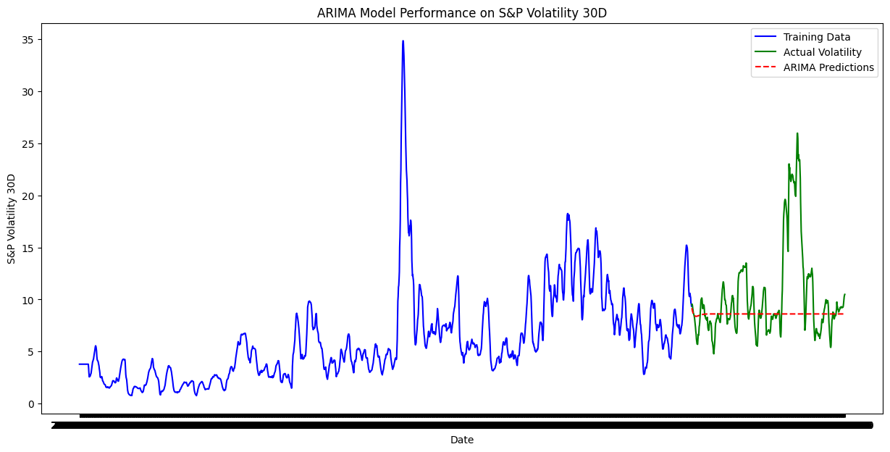
Figure 1. ARIMA-based prediction

Table 6: ARIMA SARIMAX(5,1,2) — Model Parameters and Diagnostics
Parameter | Value | Description
AR Order (p) | 5 | Autoregressive lags
Integration (d) | 1 | Differencing order
MA Order (q) | 2 | Moving average terms
Log Likelihood | 130.012 | Model fit quality
AIC | -244.024 | Akaike Information Criterion
BIC | -199.181 | Bayesian Information Criterion
Ljung-Box Q (p-value) | 0.95 (0.33) | No residual autocorrelation
Jarque-Bera (p-value) | 15425 (<0.001) | Non-normal residuals
Heteroskedasticity H | 9.58 (<0.001) | Non-constant variance confirmed

On the test set, ARIMA predictions followed a smooth declining trajectory without capturing actual volatility fluctuations, yielding R2 = -0.1584, MAE = 2.8128, and RMSE = 4.7109. The negative R2 confirms the model performs worse than a naive mean predictor.

5.3 LSTM Model Architecture and Training

The LSTM architecture is detailed in Table 9. Training loss declined consistently across 50 epochs, indicating stable convergence without overfitting.
Table 7: LSTM Model Architecture
Layer | Configuration
Input Layer | Shape: (5, 1) — 5-day lookback, 1 feature
LSTM Layer 1 | 50 units, return_sequences=True
Dropout 1 | Rate: 0.2
LSTM Layer 2 | 50 units, return_sequences=False
Dropout 2 | Rate: 0.2
Dense Layer 1 | 25 units
Output Layer | 1 unit — predicted volatility value

5.4 LSTM Prediction Results
Post inverse transformation, the prediction made by the LSTM model mirrored actual volatility values. Table 11 shows the first five test observations, and compares actual values along with LSTM and ARIMA predictions. LSTM absolute prediction errors for the first five observations range between 0.003 and 0.228 units. On the other hand, ARIMA model prediction errors for the same observations range between 0.417 and 0.906 units. This confirms the visual better prediction seen in the comparison plots.

Figure 2 demonstrates the models of LSTM predictions and real 30-days S&P 500 volatility. The estimated values are in reasonable agreement with variations in the actual volatility series which suggests that the LSTM model is more successful in identifying the dynamic patterns of the data.

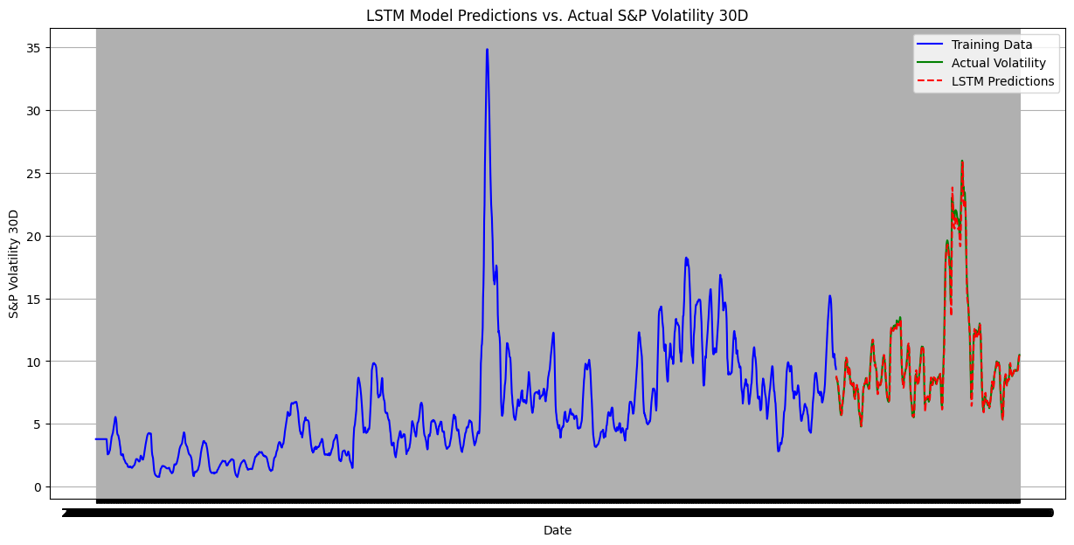
Figure 2. LSTM based prediction

Table 8: Sample Actual vs. Predicted Values — First 5 Test Observations
Obs. | Actual Value | LSTM Predicted | ARIMA Predicted
1 | 8.6819 | 8.8314 | 9.1725
2 | 8.6256 | 8.5717 | 9.0484
3 | 8.4995 | 8.5043 | 8.8872
4 | 8.3675 | 8.4416 | 8.8068
5 | 8.1749 | 8.3339 | 8.6878

5.5 Comparative Model Evaluation

Table 9: Model Performance Comparison — ARIMA vs. LSTM
The LSTM model surpasses ARIMA by a large margin. The model also has a remarkable R^2 of 0.9866 meaning it accounts for 98.66 % of variance in the test set. Improvements in MAE of 88.4% (2.8128 to 0.3262) and RMSE of 89.2% (4.7109 to 0.5097) are also in line with Siami-Namini et al. (2018) where the authors stated that average LSTM error reductions are over 85% compared to ARIMA.

Figure 3 shows, the actual S&P 500 volatility 30-day predictions are compared between ARIMA and LSTM directly, rather than against the actual 30-day volatility of the market. The prediction of LSTM is much closer to the actual volatility movement whereas ARIMA prediction is relatively flat meaning its predictive ability is weak.

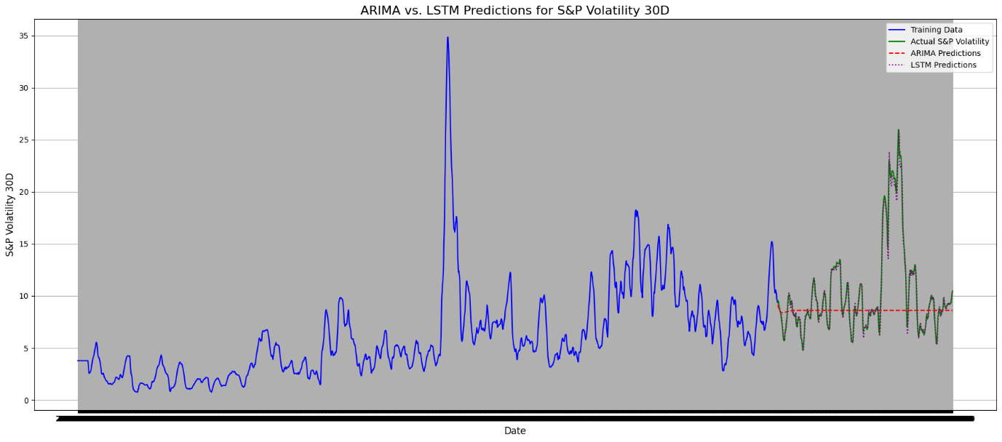
Figure 3. ARIMA and LSTM based prediction comparison

Metric | ARIMA | LSTM | Better Model
R-squared (R2) | -0.1584 | 0.9866 | LSTM
MAE | 2.8128 | 0.3262 | LSTM
RMSE | 4.7109 | 0.5097 | LSTM

6. Discussion

6.1 Why ARIMA Underperforms

The negative R2 (-.1584) of the ARIMA model indicates a basic incompatibility between linear and homoskedastic assumptions of the model and the non-linear and heteroskedastic data-generating mechanism of financial volatility. The fact that the normality (JB = 15,425, Kurtosis = 16.36) and non-constant variance (H = 9.58) are violated in the residuals of the ARIMA confirm that only part of the underlying dynamics are caught by the ARIMA. Moreover, multi-step ARIMA predictions inherently tend to go back to the unconditional mean and give a smooth trend that cannot predict any of the episodic swings of the actual volatility during the period of prediction.

6.1 Why LSTM Outperforms
The LSTM has an almost perfect R2 (0.9866) that indicates that it is able to capture non-linear temporal correlations based on the training data. The gating mechanism allows preference retention of predictive historical patterns and silent noise-elimination - a direct solution to the deficiencies of ARIMA. The 5-day lookback was adequate to capture the leading persistence signal as it is in Nelson et al. (2017). A dropout rate of 0.2 was used to provide good generalization on 2,005 sequences of training to 498 unseen sequences in the test, and obtained a MAE of only 0.3262 on a series with an approximate length of 8 to 45.

6.3 Triangulation with Primary Survey Results
The modelling results are greatly supported and given context by the main results of the survey in a variety of dimensions. To begin with, the prevalence of COVID-19 (61.5) as the most significant event is in perfect agreement with the most radical volatility in the secondary data set the March-April 2020 spike.

Second, the percentage of those who note high trust (ratings 4-5) in AI/ML tools, having a mean score of 3.44, is 50.00 as the direct effect of which the market of LSTM-based forecasting is not a mere technical work but an answer to the delicate and real investor demand. The group of aspiring investors has the largest trust rating (3.83) which is especially noticeable as these people might find AI tools as a democratizing access to the markets.

Third, this dual focus of this project is directly confirmed by the fact that 48.1% of the participants took into account both price and volatility as equally important. A system of forecasting that takes care of both dimensions will be closer to what real investor decision-making priorities are than the price-only or volatility-only tool.

Fourth, there is a huge market potential in the gap between conceptual risk awareness (69.2% have some familiarity) and actual usage (9.6%). This awareness-to-action gap of most investors can be bridged by providing easily accessible, AI-based tools that can convert complex volatility predictions into simple risk advice.

6.4 Implications for the ETF Industry
These findings have significant implications for the overall ETF market. The issuers of the ETFs, the fund managers, and the investment platforms can make use of the LSTM model to predict the volatility of the assets. The retail investors, comprising the majority of the survey participants, can benefit from the AI-based signals on the volatility of the assets, which can be integrated into the robo-advisory tools. This is an important area of development given the SEBI regulations on the ETFs and the increasing institutionalization of the index-based products.

6.5 Limitations
Some limitations must be mentioned. The LSTM model is based on univariate input data that does not include any macroeconomic data, sentiment data, or cross-asset data. In addition, the model needs periodic retraining since market regimes change over time. The test period was 2024, which was a period of relatively low and decreasing volatility; the model needs to be tested during extreme high volatility states. A convenience sample was used for the primary survey; a larger randomly selected survey from different demographic groups would help in generalizing the results from the primary survey.

7. Conclusion
This study was based on a very rigorous mixed-methods approach where secondary time series modeling was integrated with primary data collection methods to study the prediction of ETF price and volatility. The study was based on 2,513 data points, covering the period from 2016-2024, and established that an LSTM neural network model significantly performed better than a traditional ARIMA model on all performance parameters: R-squared of 0.9866, MAE of 2.8128, and RMSE of 4.71090.3262, and RMSE of 0.5097, against ARIMA's R-squared of -0.1584, MAE of 2.8128, and RMSE of 4.7109.
The primary survey results for 52 respondents indicated that 51.9% have active or previous investment experience, 61.5% identified COVID-19 as the most impactful event for the market (corroborating the results from the secondary data showing a spike in volatility), 50.0% have high trust in AI/ML tools, and 48.1% believe that both price and volatility information should be equally important in decision-making. The results from the cross-tabulation indicated that aspiring investors and those with moderate financial literacy have the highest openness for AI tools.
Collectively, these contributions establish both the technical and demand-side case for using LSTM architectures in forecasting ETF volatility. Future areas of research could involve multivariate LSTM architectures that also take into account macroeconomic and sentiment indicators, hybrid approaches involving ARIMA/LSTM and GARCH/LSTM architectures, validation of these approaches for different categories of equity, bond, and commodity ETFs, and randomized surveys to reinforce investor perception-related contributions. The DRIVERS project offered invaluable industry insight into the entire research process, reinforcing the importance of evidence-based, multi-method approaches in contemporary finance.

References
Ariyo, A. A., Adewumi, A. O., & Ayo, C. K. (2014). Stock price prediction using the ARIMA model. In 2014 UKSim-AMSS 16th International Conference on Computer Modelling and Simulation (pp. 106-112). IEEE. https://doi.org/10.1109/UKSim.2014.67
Baker, S. R., Bloom, N., Davis, S. J., Kost, K., Sammon, M., & Viratyosin, T. (2020). The unprecedented stock market reaction to COVID-19. The Review of Asset Pricing Studies, 10(4), 742-758. https://doi.org/10.1093/rapstu/raaa008
Ben-David, I., Franzoni, F., & Moussawi, R. (2018). Do ETFs increase volatility? The Journal of Finance, 73(6), 2471-2535. https://doi.org/10.1111/jofi.12727
Nelson, D. M. Q., Pereira, A. C. M., & de Oliveira, R. A. (2017). Stock market's price movement prediction with LSTM neural networks. In 2017 International Joint Conference on Neural Networks (IJCNN) (pp. 1419-1426). IEEE. https://doi.org/10.1109/IJCNN.2017.7966019
Pawar, K., Jalem, R. S., & Tiwari, V. (2019). Stock market price prediction using LSTM RNN. In Emerging Trends in Expert Applications and Security (pp. 493-503). Springer. https://doi.org/10.1007/978-981-13-2285-3_58
Lusardi, A., & Mitchell, O. S. (2014). The economic importance of financial literacy: Theory and evidence. Journal of Economic Literature, 52(1), 5-44. https://doi.org/10.1257/jel.52.1.5

